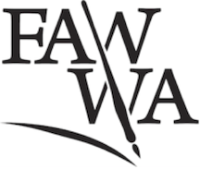

Fellowship of Australian Writers WA

Membership Form

1st July 2021 until 30th June 2022

Join the FAWWA community and receive regular updates on events and opportunities for writers. Enjoy discounts on workshops and events run by WAPI, PCWC, OOTA and KSP. Please fill out the form below and email to: fellowshipaustralianwriterswa@gmail.com
or post to:
FAWWA
PO Box 6180
Swanbourne WA 6910

NAME:

ADDRESS:

MOBILE:

EMAIL:

PAYMENT TYPE $65 (full) $50 (concession) $30 (student)

PAYMENT METHOD

Cheque/Cash

Pay through PayPal.Me/FAWWA -
where it says 'Add a note', please put your last name and ‘Memb’

Direct Debit

Pay to Bankwest (Fellowship of Australian Writers WA)
BSB 302-162
ACC 0969363
Reference your surname and ‘Memb’

Signed Date

The Fellowship of Australian Writers WA was founded in 1938 to support Western Australian writers and their work.
​
Today we are based at Mattie Furphy House in Swanbourne where we program creative writing classes, author talks and writing groups. We also provide reasonably priced space to other creatives.

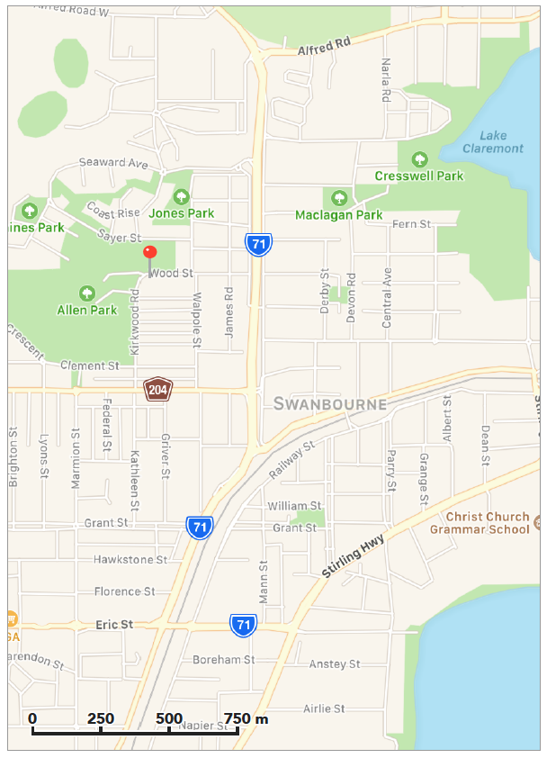

​Annual Competitions

The Tom Collins Poetry Prize opens for submissions on October 1 each year. First place is $1000 + two weeks residency at Mattie Furphy House.

The Stuart / Hadow Short Story competition opens on March 15 every year. First place is $1000 + two weeks residency at Mattie Furphy House.

Phone: 9384 4771 (Office hours are 10-3pm Tues and Fri)
Email: fellowshipaustralianwriterswa@gmail.com
website https://www.fawwa.org/

Look out for us on Facebook and Instagram

